Using Collections
This lab sheet isn’t intended to take you step by step through writing the code, but to introduce the idea of collections in javascript.
Consider the classic game space invaders…
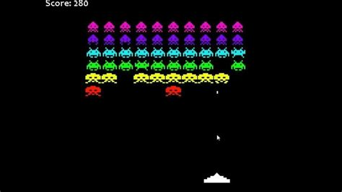
Here is a question, how many sprites do you see?
I see three.
Why?
One for the gun at the bottom of the screen…

One for the bullets…
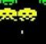
One for the space invaders…
The point is that even though there are 60 space invaders at the start of the game they are all the same sprite. The fact that each space invader looks slightly different is irrelevant, functionally they are all identical, the cosmetic changes are just that, cosmetic.
Start by opening the file space lander 9 and run the page lander.html, you should see the following…
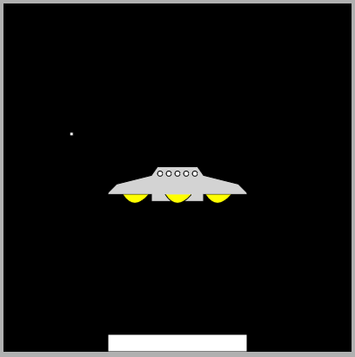
Notice the single star in the background. The graphic isn’t very advanced and all it does is drift from right to left and then reappear on the right.
Now run the page lander_collection.html and you should see something like this…
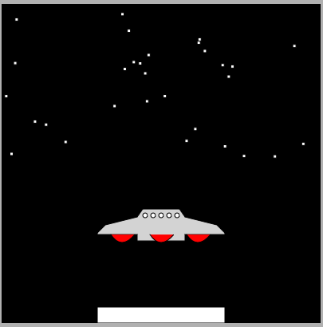
In this example we have 30 stars all behaving the same way.
So how did we get here?
The important point is that we use object orientation to write the code for one star and then clone it by making multiple instances of the original class code.
To make it work we have had to make a few changes to the design of the sprite.
Here is the code for the star sprite, star.js…
//create the constructor for the class square
function Star() {
//initialisation code will go here

//create private variables for the x and y coordinates
this.x = Math.random() * 400;
this.y = Math.random() * 200;
//set the size of the star
var size = 2;

Star.prototype.draw = function (context) {
//save the state of the drawing context before we change it
context.save();
context.fillStyle = "#FFFFFF";
//set the coordinates of the drawing area of the new shape to x and y
context.translate(this.x, this.y);
//start the line (path)
context.beginPath();
context.moveTo(-size, size);
context.lineTo(size, size);
context.lineTo(size, -size);
context.lineTo(size, -size);
context.lineTo(-size, -size);
//context.lineTo(0, 0);
//close the path
context.closePath();
context.fill();
//go ahead and draw the line
context.stroke();
//restore the state of the context to what it was before our drawing
context.restore();
}

Star.prototype.move = function () {
//change the x axis
this.x -= .1;
//if the star has drifted off the left of the canvas
if (this.x < 0) {
//place it at the right of the canvas
this.x = 400;
//set the y value to a random position
this.y = Math.random() * 200;
}
}
}
Much of the code should be familiar. We have a draw method to draw the sprite, we also have a move method to make the sprite move.
Note that we have changed the way that we generate public properties, from something like this…
//create private variables for the x and y coordinates
var x = 0,
y = 0

//create a public property called X (note caps!)
Object.defineProperty(this, 'X',
{
//getter
get: function () {
//return the value of x (lower case)
return x;
},
//setter
set: function (value) {
//ste the value of x (lower case)
x = value;
}
}
)
To the following…
//create private variables for the x and y coordinates
this.x = Math.random() * 400;
this.y = Math.random() * 200;

The first approach to creating public properties is good on solid practice but it actually won’t work the way we expect when we implement the collection. If we take this approach all items in the collection share the same property values which creates some very odd effects.
To get round this problem we use the keyword “this”
this.x = Math.random() * 400;

By using this.x we create a public property with no private data member. From an object orientation point of view this is bad so far as getting the job done it is good. (Trust me on this!)

Notice how we are initialising the public properties using Math.random()

The first one generates a number between 0 and 400, the second a random number between 0 and 200.

Note that in the class code when we want to reference these properties we need to reference “this”, e.g…

Star.prototype.move = function () {
//change the x axis
this.x -= .1;
//if the star has drifted off the left of the canvas
if (this.x < 0) {
//place it at the right of the canvas
this.x = 400;
//set the y value to a random position
this.y = Math.random() * 200;
}
}

It is likely that you will need to adapt your existing code should you wish to use a sprite as part of a collection.

“This” is shorthand for “this object”.

The Collection Class
To make this work you will need to add the javascript collection class into your project available in this demo project…

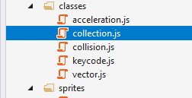

Once the class is created in your own work you will need to add a reference to it in the html like so…

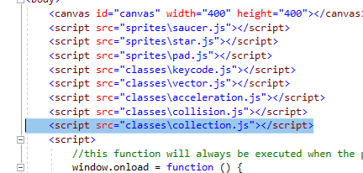

The next step is to declare the collection class like so…

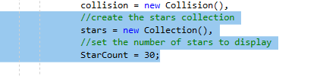
Clearly you will need to decide on an appropriate name for the class.

Note that I have in my example also added a variable called StarCount. The idea is that if I want to display more or fewer stars, I can change this value as I need.

Next I need three functions to do the following…

- Initialise the collection adding the items I need and setting any properties if needed
- Draw the objects in the collection
- Move the objects in the collection

Here is the code for these three functions…

//used to initialise the collection
function InitStars() {
//var for loop counter
var count = 0
//wile counter less than star count
while (count < StarCount) {
//create a new star
star = new Star();
//add the star to the collection
stars.add(star);
//inc the counter
count++;
}
}

//used to draw the stars collection
function DrawStars() {
//var for loop counter
var count = 0
//wile counter less than star count
while (count < StarCount) {
//draw star at index
stars.item(count).draw(context);
//inc the counter
count++;
}
}

//used to move the stars
function MoveStars() {
//var for loop counter
var count = 0
//wile counter less than star count
while (count < StarCount) {
//move the star at the index
stars.item(count).move();
//inc the counter
count++;
}
}

You should have the bulk of this functionality in place for any sprite you want to turn into a collection.

You will need to call the initialisation function early on in the set up like so…

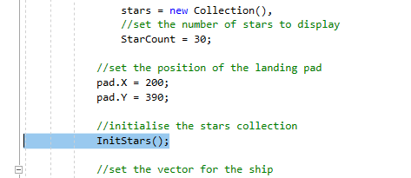

Inside your draw frame function you will need to call the other two functions.

In the non collection version of the function we have the following code to draw and move a single star…

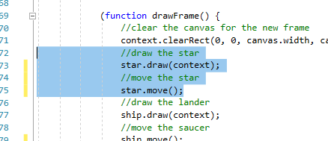

All we need to do to use the collection class is to make use of the two functions we have created above like so…

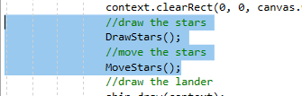

That is pretty much it. If you have made the original sprite behave correctly when you first designed it, the sprite will behave in exactly the same manner but this time with multiple independent copies of the original.

